Motorola Edge 30 NEO 5G

Type of device: Mobile
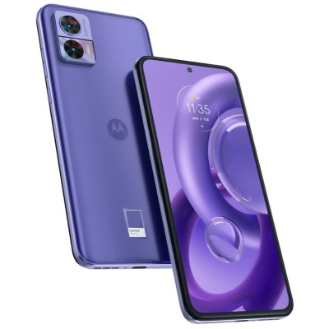

Actual Display Size : 6.28 inches
Button Type : Touchscreen
Operating System : Android
Version Number : Android 12
Network Capability : 3G,4G,5G
Year of Release : 2022
Average Price : $509 as of 22 11 2022

Accessibility Features:

Cognitive
- Additional Instructions
- Copy and Paste
- GPS
- Photo Telephone List
- Screen Timeout Disabled
- Simple Instructions
- Simple Reminders
- Simplify Display
Voice Notes

Hearing Impairment and Deaf
- Allows for sign language communication
- Bluetooth or Wi-Fi
- Closed Captioning
- Front Facing Camera
- Hearing Aid Microphone Coupling
- Hearing Aid Telecoil Coupling
- Text Messaging/SMS
- Vibrating Alerts - Adjustable
- Video Communications - Two-way
Visual Alerts - Incoming Calls

Vision
- Battery Alert - Audible
- Bluetooth or Wi-Fi
- Braille Display Support
- Brightness Adjustable
- Dictation / Speech-to-Text
- High Contrast Mode
- Personalised Shortcuts
- Power Cue
- Screen Magnifier
- Screen Reader
- Text Size Adjustable
- Text Style Adjustable
- Voice Control /Personal Assistant
Voiced Menus

Speech
- Allows for sign language communication
- Bluetooth or Wi-Fi
- Messaging Options - Email
- Messaging Options - IM
- Messaging Options - MMS
- Predictive Text
SMS Personalisation and Reuse

Physical
- Automatic Answer
- Bluetooth or Wi-Fi
- Dictation / Speech-to-Text
- Gesture Based Navigation
- Headset - plug connected
- Predictive Text
- Speaker-phone option
- Stylus or Prosthetic Device support
- Switch control option
- Voice Control / Personal Assistant
- Voice Recognition for Accessing Features
Voice Recognition for Dialling

How and where to get it from?
You can buy this phone from JB Hi-Fi, The Good Guys, and other retailers.

More information is available on:
Motorola Edge 30 Neo 5G User Guide webpage
Motorola Edge 30 Neo 5G webpage

